Jeremy Lewis: Maintaining positive energy and emotion in these challenging times  May 12th 11:00 - 11:45  Jeremy Lewis will explore the impact our own emotional response to the crisis is having on our ability to remain energised in our work. How can we be at our best and help our clients find balance and meaning in their work and home life? | Julia Felton: The power of coaching with nature: How nature based coaching can improve wellbeing and deliver improved business performance  May 12th 12.00 - 12.45  What can you learn from nature today to improve your life and business? Julia will share a five step nature coaching process and how you can beneficially integrate this into your life on a daily basis. | Cheryl Winter: Don’t give me boundaries, even though I need them  May 12th 13.00 - 13.45  Whether you are coaching ADHD clients, managing team members with ADHD or you yourself have your own wonderful diagnosis of ADHD Cheryl will explore the theme of boundaries, with tips appropriate to the creative and novel style which ADHDers adore. You will hear practical real life stories mixed with text book theories. | Janette Poole: Building resilience in uncertain times. Are you a tomato or a tennis ball?  May 12th 15.00 - 15.45  Resilience is our ability to bounce back when faced with setbacks and challenges in our personal and professional life. It is not a rare quality but is something that we can all develop. This webinar will help you understand your resilience level and what may be affecting it, in particular during these uncertain and challenging times. Jeanette will share some tools and techniques to enable you to increase your resilience, and we’ll explore whether you’re a tomato or a tennis ball. | 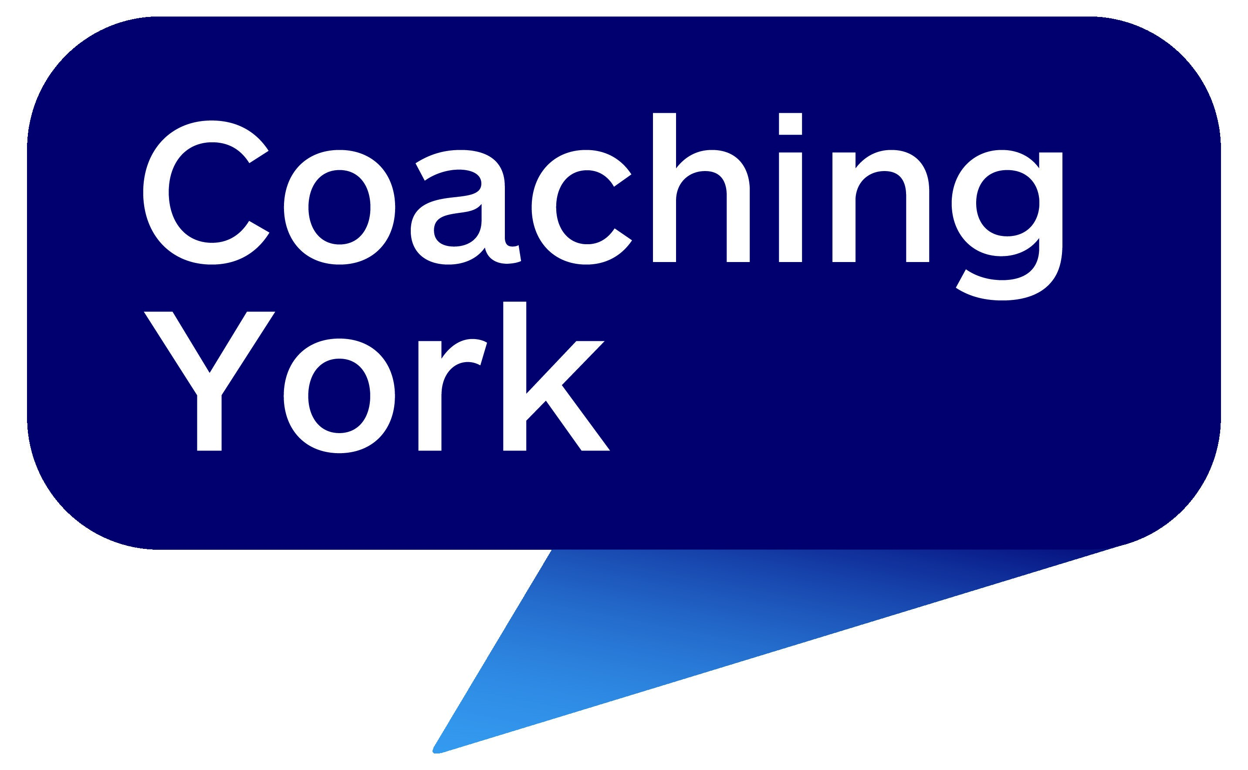  2020  International  Coaching  Week 2
Harriet Kretschmar: How to become a mindful leader in agile times?  May 13th 10:00- 10:45  Based on a mindful leadership project carried out in a German factory of a multinational company, we will explore what it takes to become more mindful as an agile leader, and why this is even more important for leaders from Scrum masters to senior management. | Steve Gorton & Geoff Ashton: How to lead when the past is a poor guide for the future  May 13th 14.00 -14.45  Uncertainty can find us down in the weeds, repeating what no longer works as well as before. It’s like being on a crowded dance floor, our view limited to the technical moves. But we can “get on the balcony” see the bigger picture and adapt accordingly, making changes that bring others along to be successful. This session provides a framework to assess when to take a new approach, a process to explore changes to make and five practical strategies to deliver that new approach. | Bryony Rountree: Putting your gas mask on first: Essential Leadership selfcare  May 14th 10:00 - 10:45  To take care of yourself as a leader, whilst holding your team, navigating these unprecedented, challenging, uncertain times and managing a different workload, it is essential that you sustain yourself. This webinar offers tools for doing your own ‘temperature check’, becoming more aware of where you are focusing your time and energy and bringing yourself back to anchor, to lead from a more grounded place; improving your impact and allowing you to live and work with more ease and have space to breathe. | Sarah Nicholson: Navigating change and strengthening resilience  May 14th 11.30 - 13.00  A 90 minute workshop to make time to get clarity. If your brain currently feels like a ball of spaghetti, clarity is very empowering. You will step out of the overwhelm and analyse your perspective. Understanding the processes you are going through, enables you to be more comfortable in your current place in life. Receive tools to manage fear and connect with your inner guidance and access your next steps. | Webinar  Programme  More details  and  to book  just click  here

